As of 01-02-2020 there are several issues with preparing NJ amended returns with TSO.
- If you need to change filing status to or from Married filing joint, then it will not be possible to enter some of the basic information properly because TSO asks some questions based on the current return filing status, not the original return filing status.
- If any of the following are part of the original return, then there is no place to enter the original NJ return amount in TSO:
  - NJ-1040, Line 9 (Veteran Exemption for TP/SP)
  - NJ-1040, Line 34 (Health Enterprise Zone Deduction) [Out of Scope?]
  - NJ-1040, Line 35 (Alternative Business Calculation Adjustment) [Out of Scope?]
  - NJ-1040, Line 44 (Child and Dependent Care Credit)
  - NJ-1040, Line 48 (Gold Star Family Counseling Credit)
  - NJ-1040, Line 51 (Interest on Underpayment of Estimated Tax)
  - NJ-1040, Line 60 (Wounded Warrior Caregivers Credit)
You will need to manually fill in the NJ-1040X for the above situations. It is available as an online fillable form from the NJ website.
It might still make sense to prepare an amended return in TSO by entering information in alternate boxes and adjusting your entries for the manually filled in NJ-1040X. Whether this makes sense and exactly how to use TSO to help will depend on the exact nature of the return
If you’re not sure how to handle the above issues in TSO, seek the help of a more experienced volunteer. If necessary, you can always send TP to a paid preparer (or the whoever prepared the original return).

This document shows you the steps to get to the data entry screens for the NJ-1040X “Original Return” column.
As you go through the detail pages, the NJ-1040 line numbers are identified for each box.
When you get to one of the lines related to the above list of issues in the detail pages, it will be identified as missing. Lines which do not need to be entered on the original return detail pages because they are calculated are also identified.

How to create a NJ amended return and get to the NJ screens for entering Original amounts
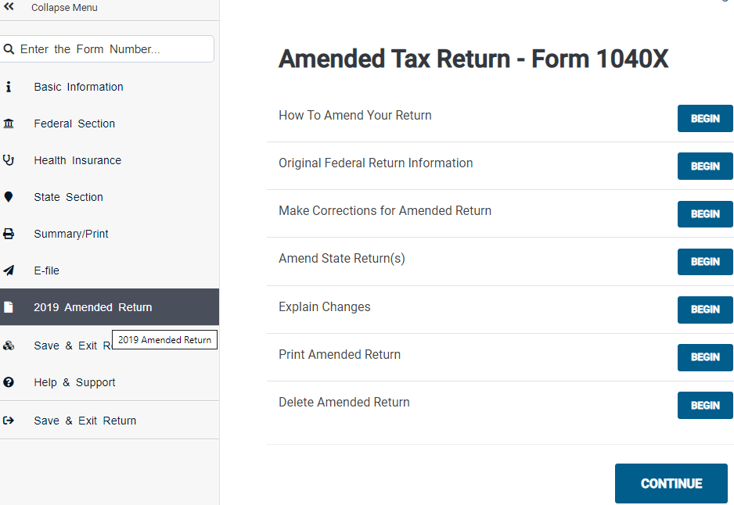
Step 2 – Click “Amend State Return(s)”
The button will read “BEGIN” before the NJ amended return is created; it will read “EDIT” if there already is a NJ amended return
Step 1 – Click on the Amended Return Menu item

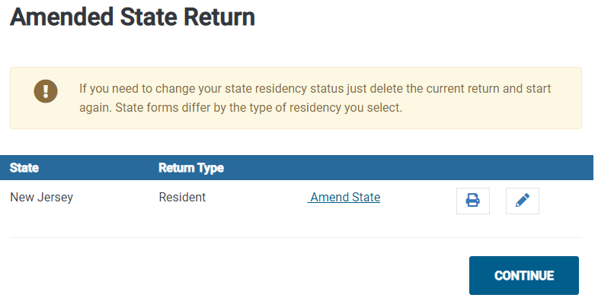
Do not click here!
Step 3 – Click “Amend State”
Note: this will change to “Edit Amended” once the NJ 1040X has been added

Note: The Property Tax and Health Care Coverage questions may come up before you get to the next step. Just answer “No” to the Property Tax question and “Yes” to the Health Care Coverage question to dismiss them and move on.
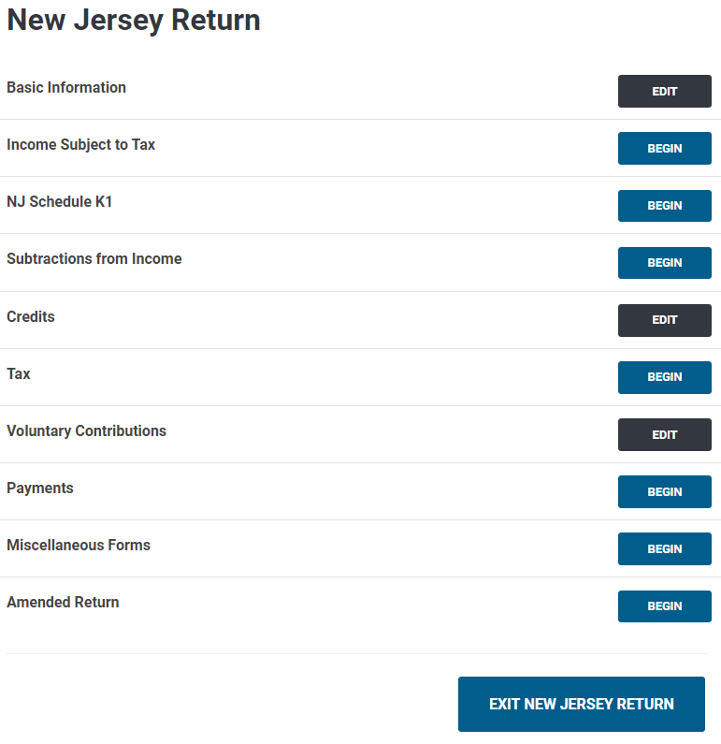
Step 4 – Click “Amended Return”
The button will read “BEGIN” before the NJ amended return is created; it will read “EDIT” if there already is a NJ amended return
Do not click any of these buttons!
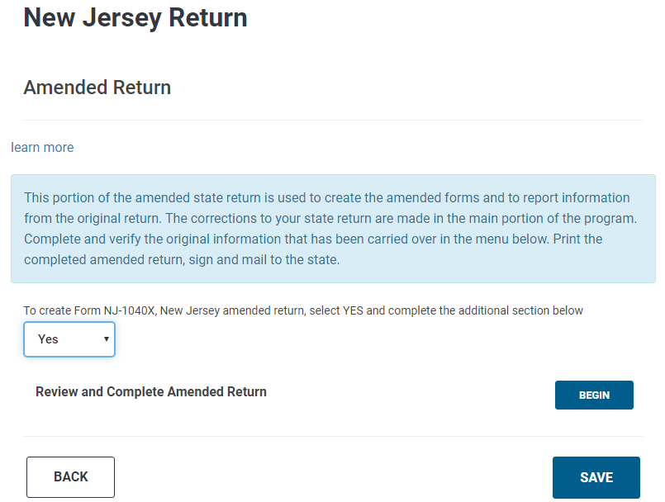
Step 6 – Click “Review and Complete Amended Return””
Step 5 – Select “Yes”

Entering NJ data for the “As Originally Reported” column is done via a menu of 9 data entry screens. You will need to manually enter information for all non-calculated lines on the original NJ return. Go through the screens one-at-a-time until all information from the original return has been entered.
The next page shows the menu of data entry screens annotated with which lines from the NJ return are covered in that screen. Succeeding pages show each screen with boxes annotated with which line from the original NJ-1040 to use.

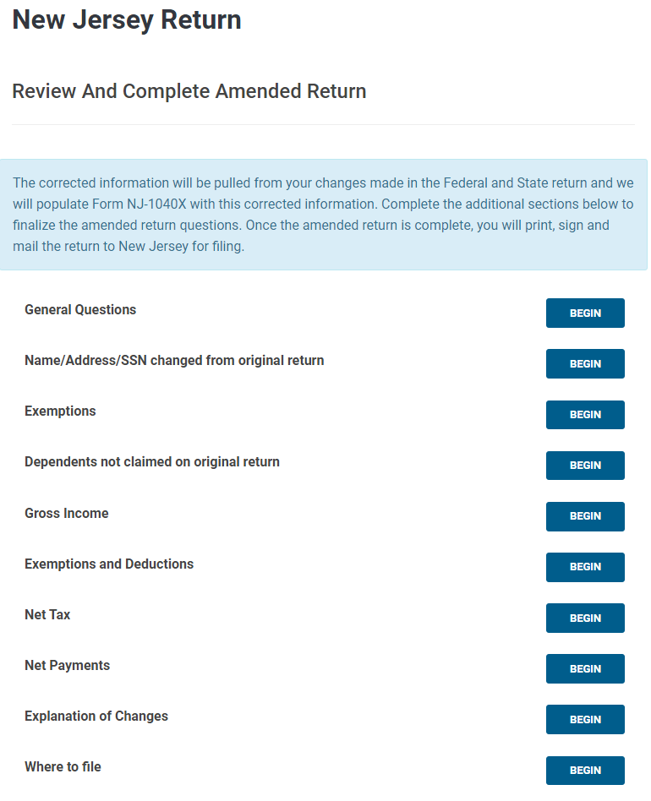
NJ-1040, Page 1
NJ-1040, Lines 6-13
NJ-1040, Lines 14a-14d
NJ-1040, Lines 15-28
NJ-1040, Lines 31-39
NJ-1040, Lines 41-53
NJ-1040, Lines 54-76
NJ-1040X Only
NJ-1040, Lines 1-5
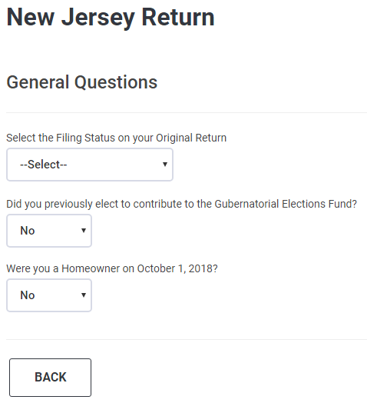
NJ-1040, Do not see on Printed Return?
NJ-1040, Page 4, No Line
NJ-1040, Lines 1-5
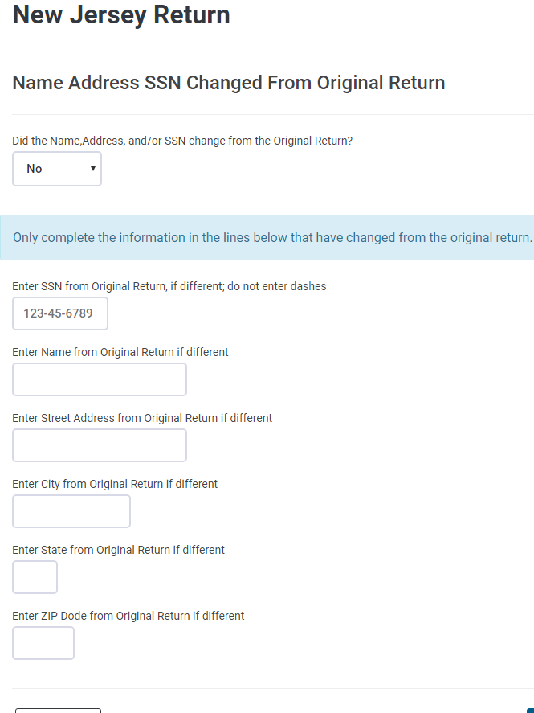
Note
NJ-1040, Top of each page (First MI Last)
NJ-1040, Page 1
NJ-1040, Page 1
NJ-1040, Page 1
NJ-1040, Page 1
NJ-1040, Top of each page
Answer as appropriate
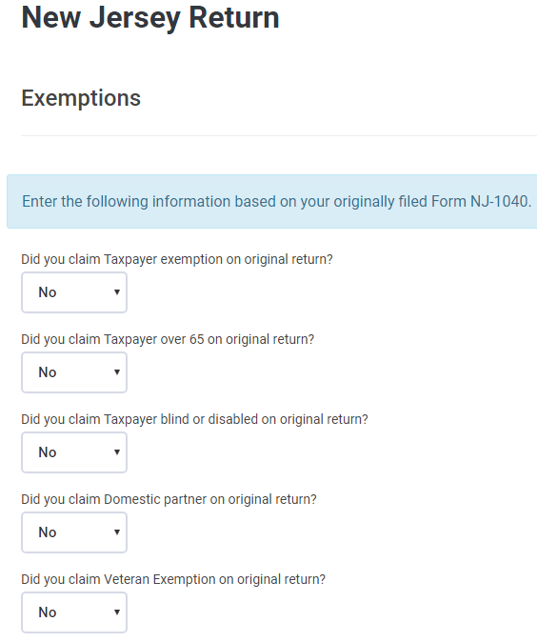
Note 1: These are asking whether the checkboxes on lines 6-9 were checked
Note 2: If MFJ, then there will also be questions for the Spouse
NJ-1040, Line 6
NJ-1040, Line 7
NJ-1040, Line 8
NJ-1040, Line 6
NJ-1040, Line 9
Note: the questions here for Lines 6 to 8(9) seem to be ignored and the numbers calculated based on the answers relating to the checkboxes above
NJ-1040, Line 9 (Veteran Exemptions) missing?
NJ-1040, Line 6
NJ-1040, Line 7
NJ-1040, Line 8
NJ-1040, Line 10
NJ-1040, Line 11
NJ-1040, Line 12
NJ-1040, Line 13
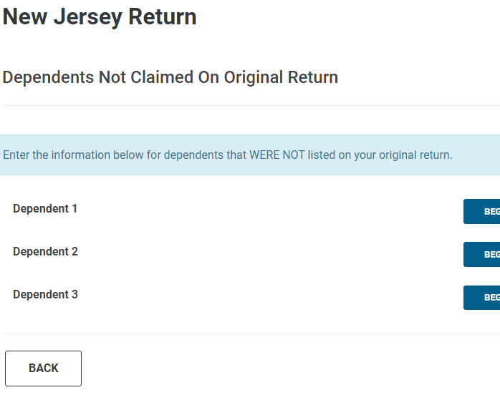
Note
NJ-1040, Line 14
NJ-1040, Line 14
NJ-1040, Line 14
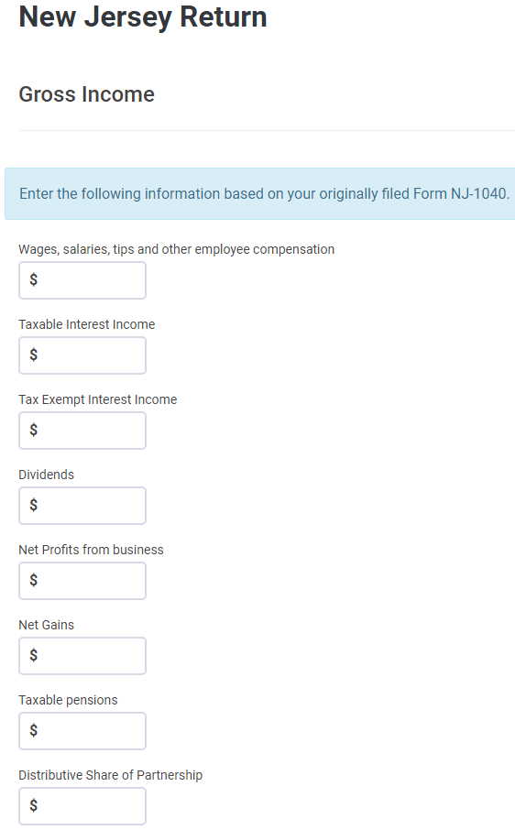
NJ-1040, Line 20b not needed
NJ-1040, Line 21
NJ-1040, Line 20a
NJ-1040, Line 19
NJ-1040, Line 18
NJ-1040, Line 17
NJ-1040, Line 16b
NJ-1040, Line 16a
NJ-1040, Line 15
NJ-1040, Line 30 calculated
NJ-1040, Line 29 calculated
NJ-1040, Line 27 calculated
NJ-1040, Line 28b
NJ-1040, Line 28a
NJ-1040, Line 26
NJ-1040, Line 25
NJ-1040, Line 24
NJ-1040, Line 23
NJ-1040, Line 22
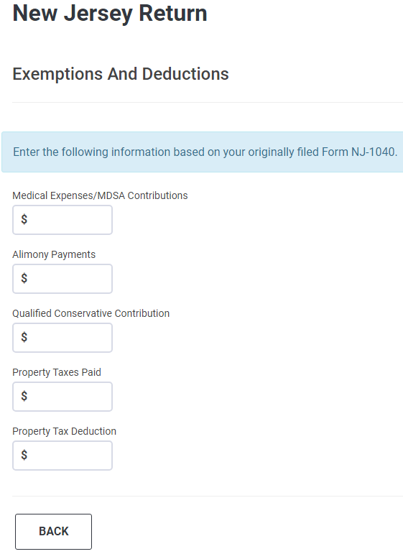
NJ-1040, Line 40 calculated
NJ-1040, Line 35 (ABCA) missing?
NJ-1040, Lines 38b-38c missing?
NJ-1040, Line 37 calculated
NJ-1040, Line 36 calculated
NJ-1040, Line 34 (HEZ) missing?
NJ-1040, Line 39
NJ-1040, Line 38a
NJ-1040, Line 33
NJ-1040, Line 32
NJ-1040, Line 31
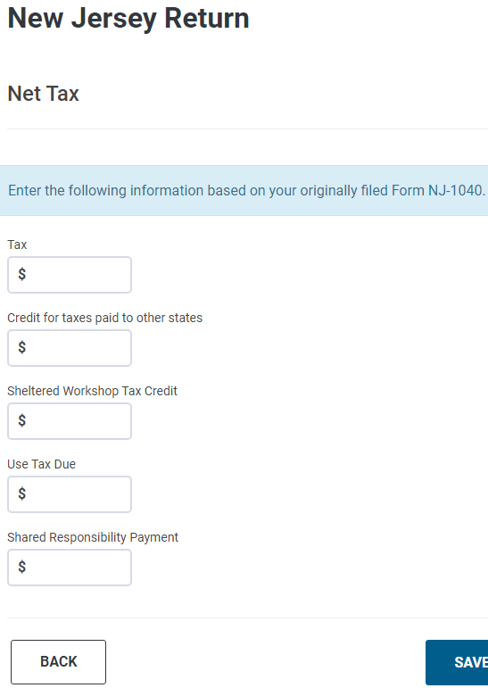
NJ-1040, Line 53 calculated
NJ-1040, Line 51 (Interest on Underpayment) missing?
NJ-1040, Line 52
NJ-1040, Line 48 (Gold Star Credit) missing?
NJ-1040, Line 44 (Dep Care Credit) missing?
NJ-1040, Line 49 calculated
NJ-1040, Line 47 calculated
NJ-1040, Line 45 calculated
NJ-1040, Line 43 calculated
NJ-1040, Line 41
NJ-1040, Line 42
NJ-1040, Line 46
NJ-1040, Line 50
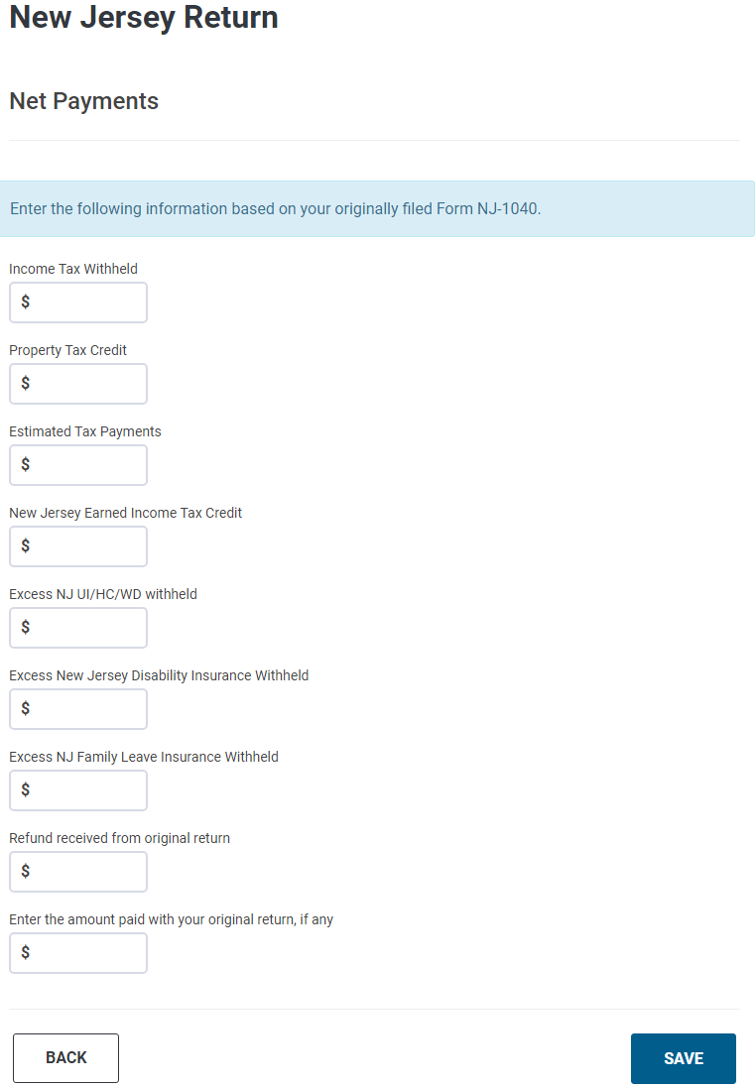
NJ-1040, Lines 65-74 not needed
NJ-1040, Lines 62-64 calculated
NJ-1040, Line 61 (Wounded Warrior) – missing?
NJ-1040, Line 54
NJ-1040, Line 55
NJ-1040, Line 56
NJ-1040, Line 57
NJ-1040, Line 58
NJ-1040, Line 59
NJ-1040, Line 60
Note: These two lines in reverse order
NJ-1040, Line 76
NJ-1040, Line 75

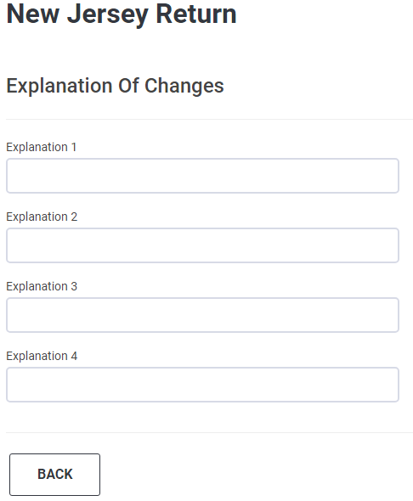

From NJ-1040X Instructions:
In the space provided, explain the reason for changes to income, deductions, and/or credits as originally reported. If additional space is needed, enclose a statement that includes your name and Social Security number.

